Create a storage account.

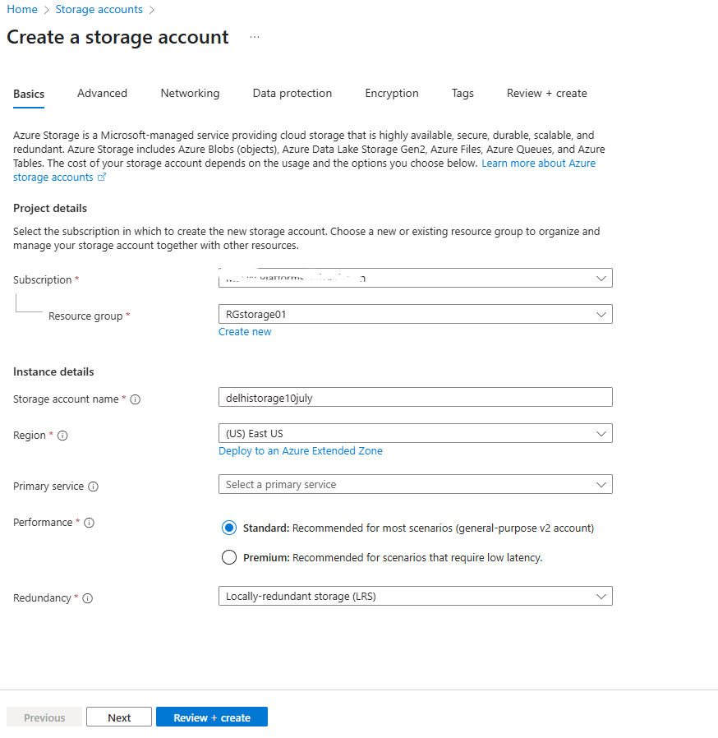

Enable the static website and create a file index.html and error.html

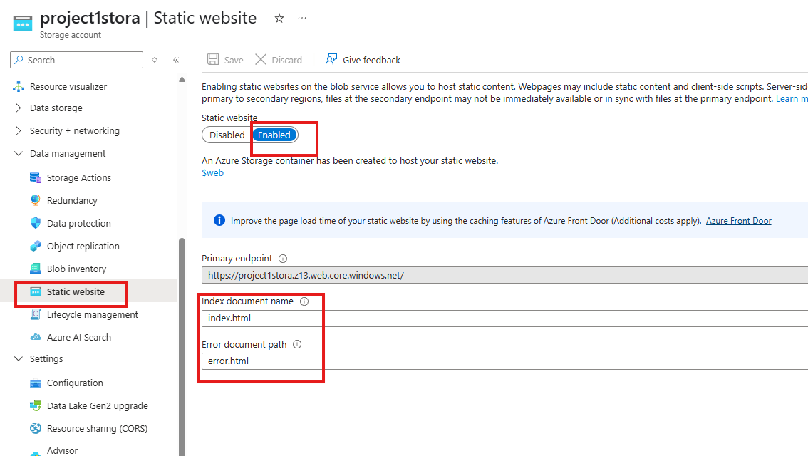

This static website hold the org’s data file to public

Create the 3 containers for different purpose. $web, $logs automatically created

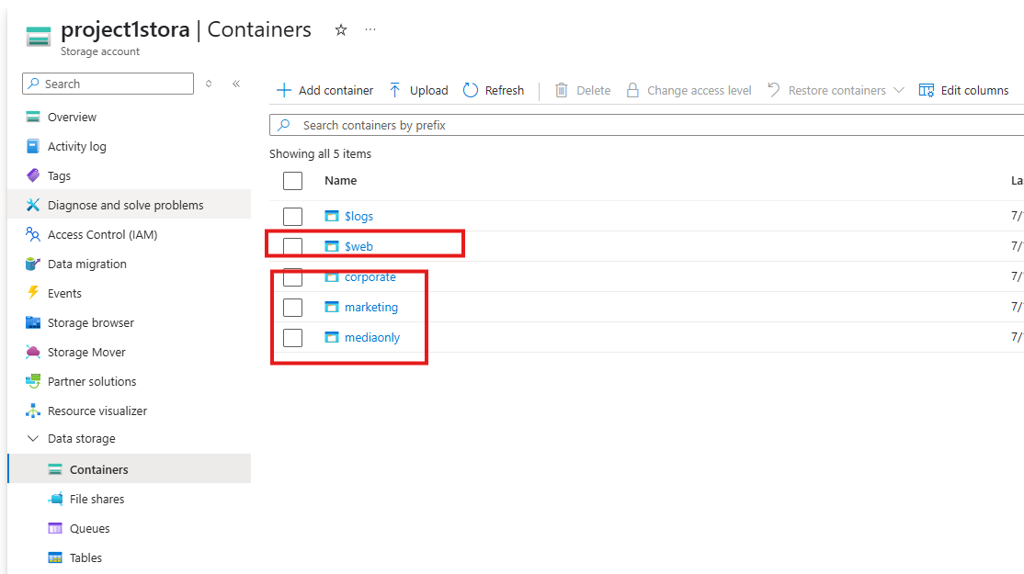

Create a file shares so user can map in their PC to use as local disk.

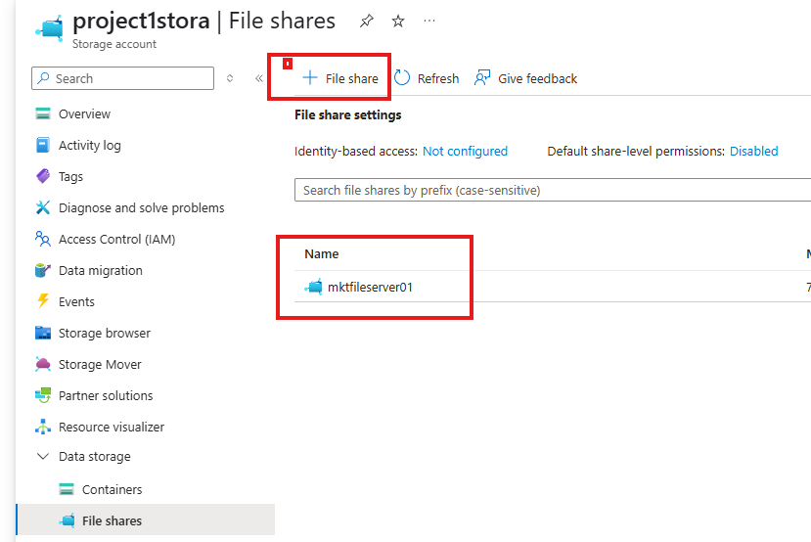

Open the file shares and click on connect.

Share the script which require to access the file share

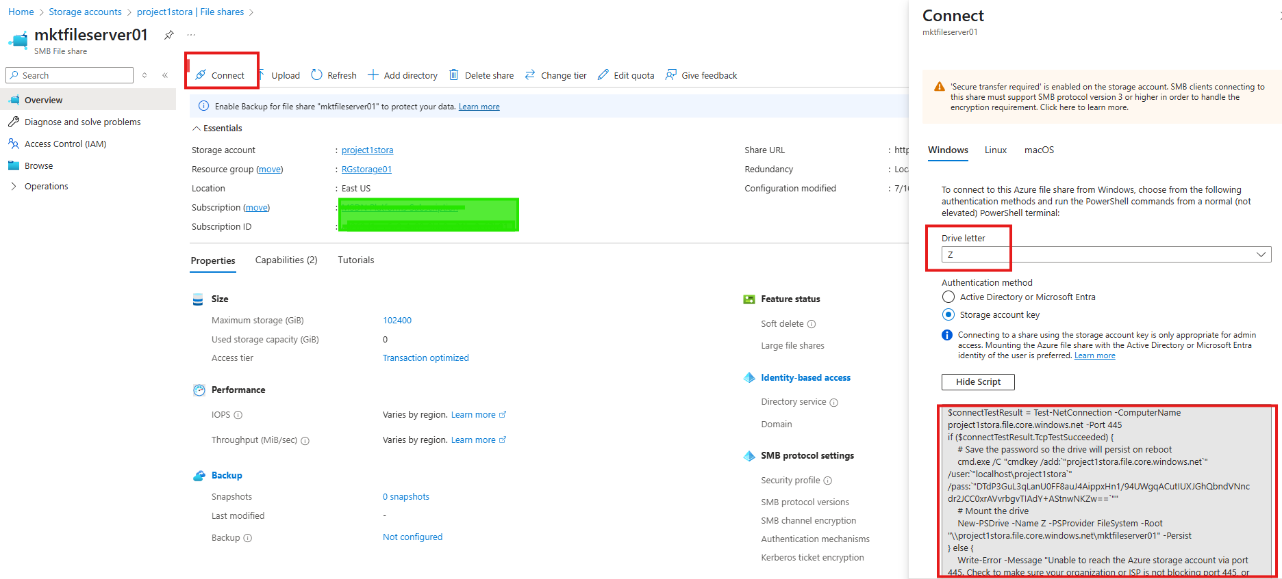

Setup the immutable blob storage access on Corporate container

